

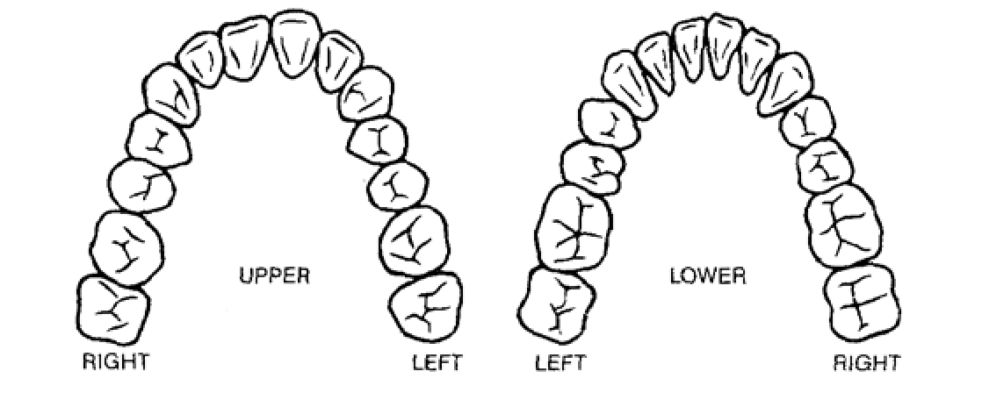

248.957.0495 • 32621

48026

Utica Road • Fraser, MI

Doctor

Address

City & Sate

Patient

Date

Return Date

**(AT LEAST 24-HRS PRIOR TO APPOINTMENT)**

**DESIGN CASE HERE**

**INSTRUCTIONS**

UPPER

Right

Right

Left

LOWER

PONTIC

SHADE

Signature

Date

License No.

Left